Azure Synapse

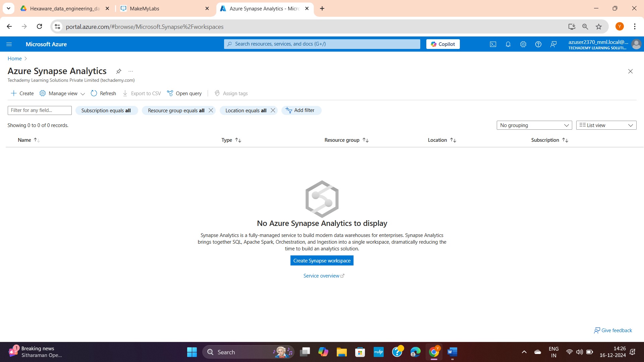

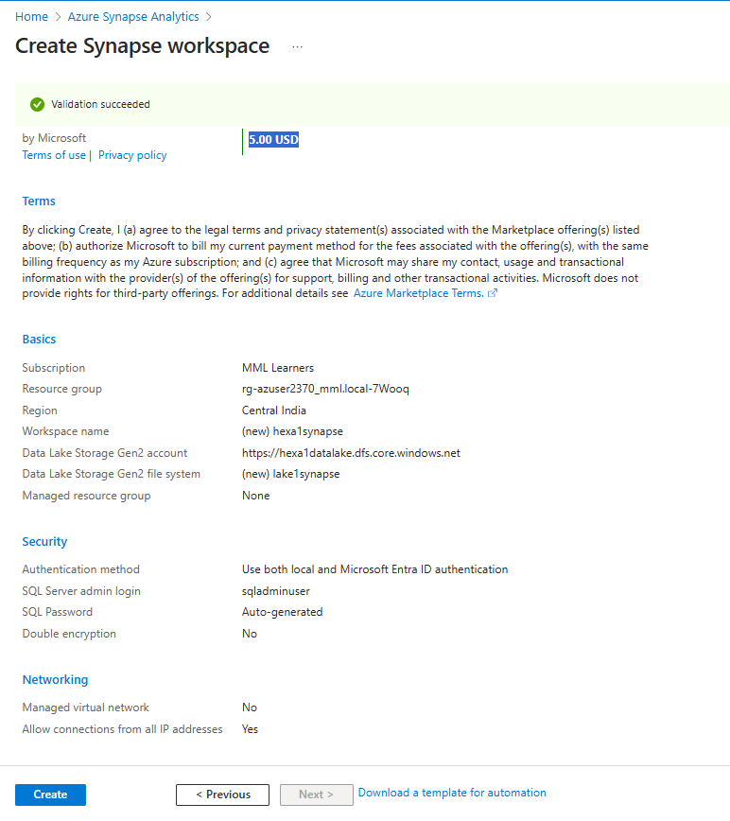

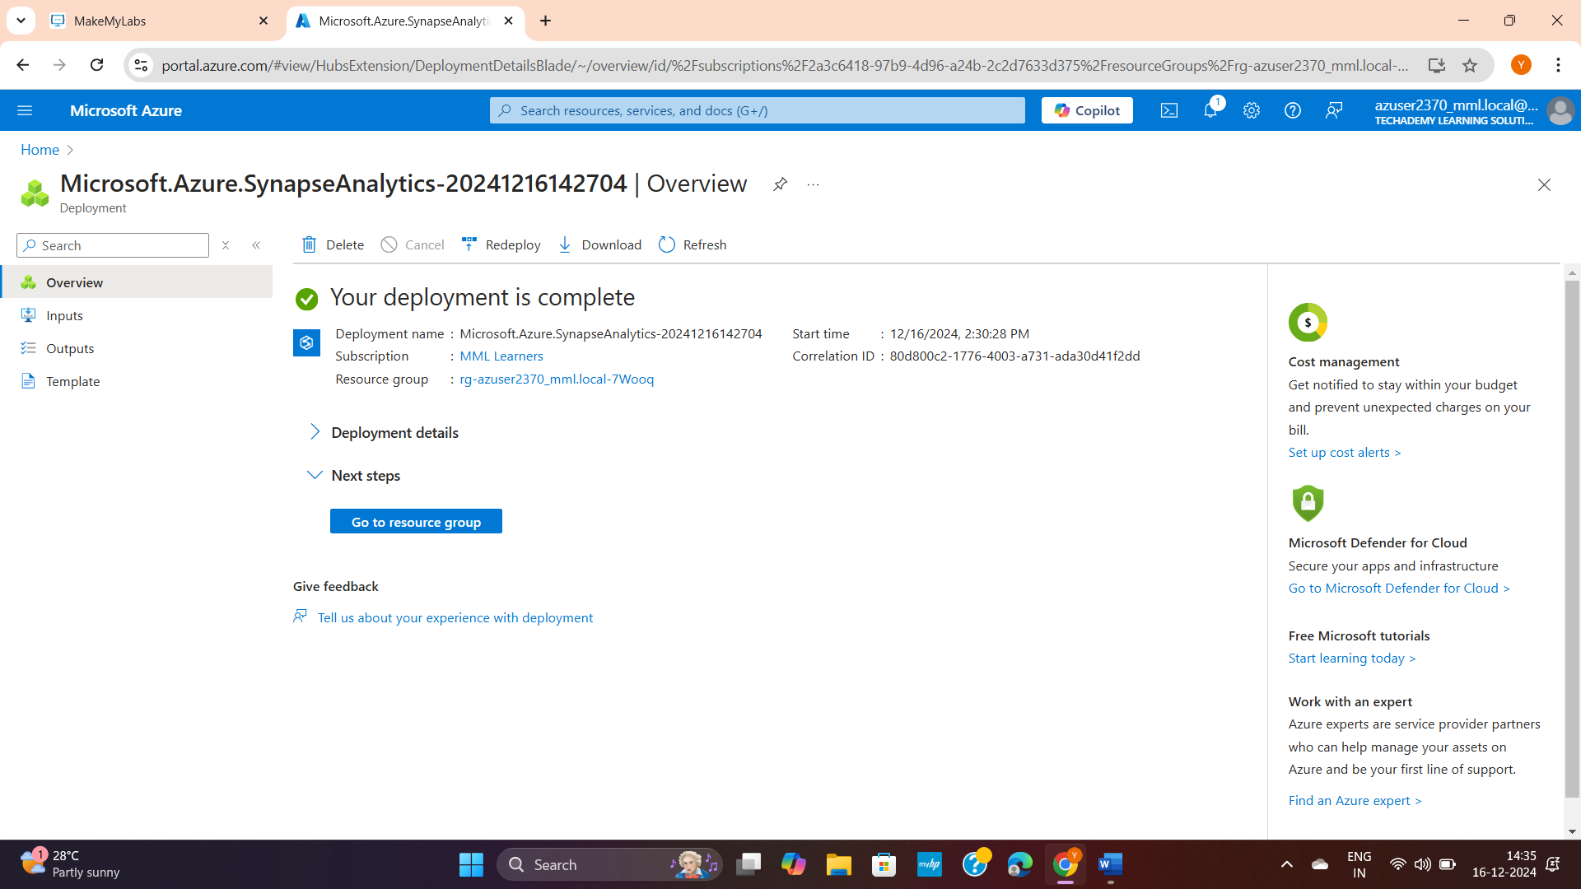

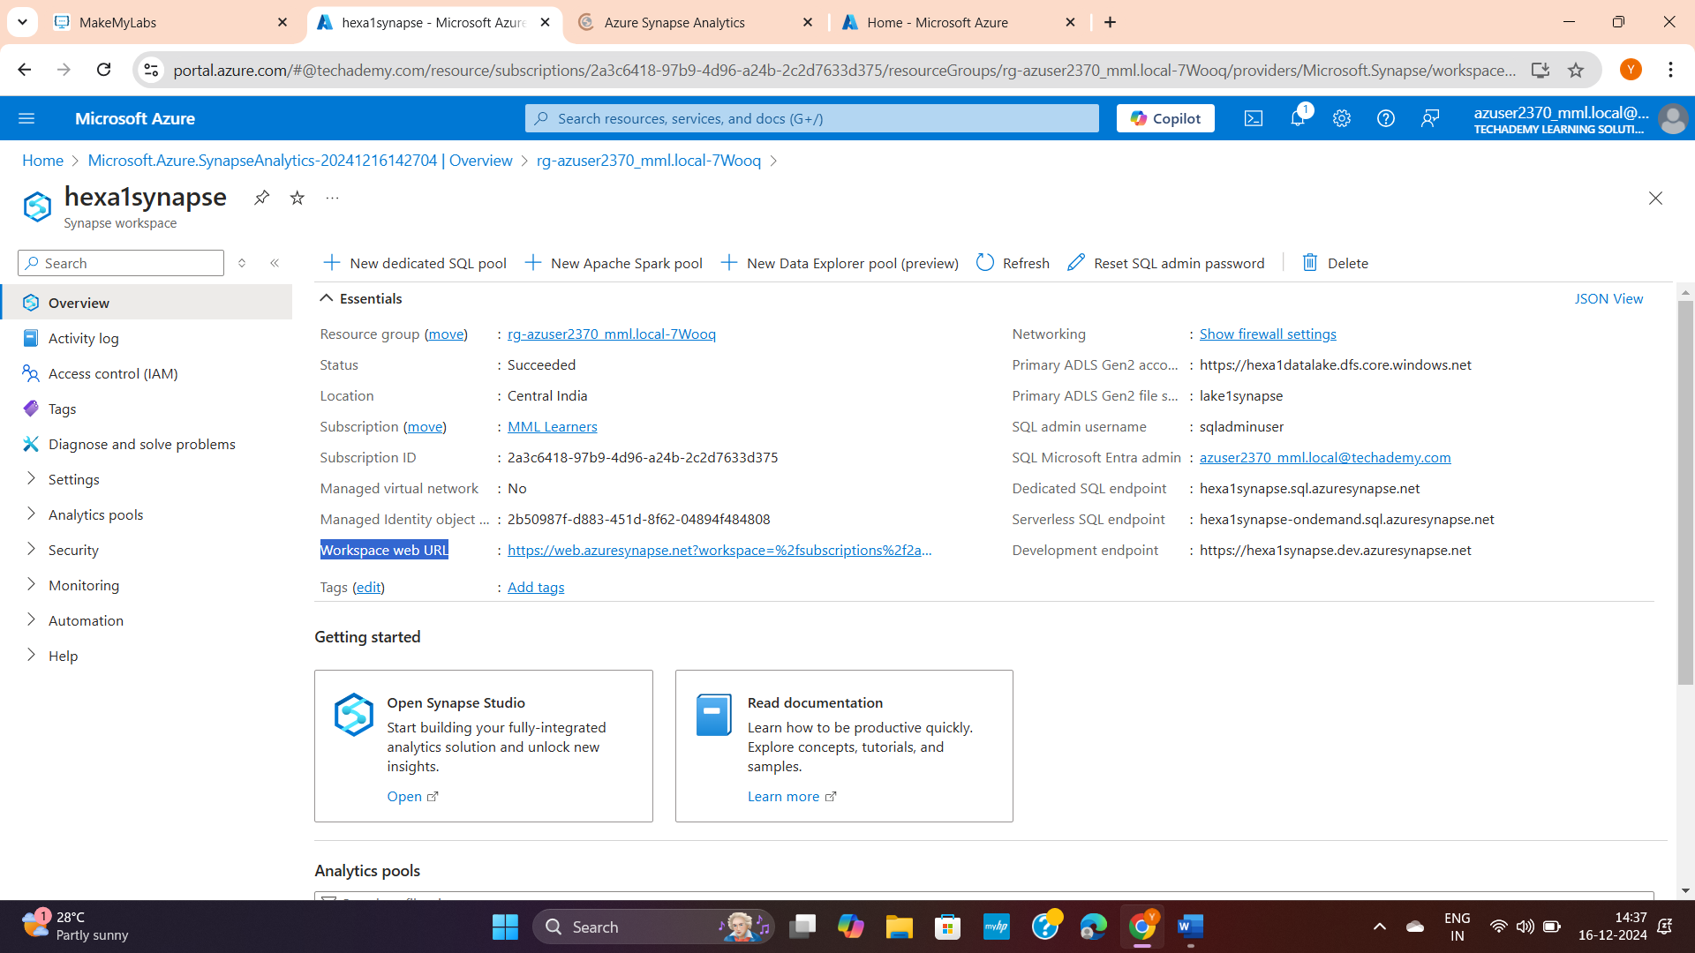

In the **Azure Portal**:

1. Navigate to your Synapse Analytics workspace.
2. Go to the **SQL pools** section under **Workspace resources**.
3. Check the pool list:
   * If it says **Built-in**, it's a serverless pool.
   * If it has a provisioned performance level (e.g., DW100c), it's a dedicated SQL pool.

**Serverless SQL Pools**:

* **Primarily used to query existing datasets in Azure Data Lake** without ingesting or transforming them.

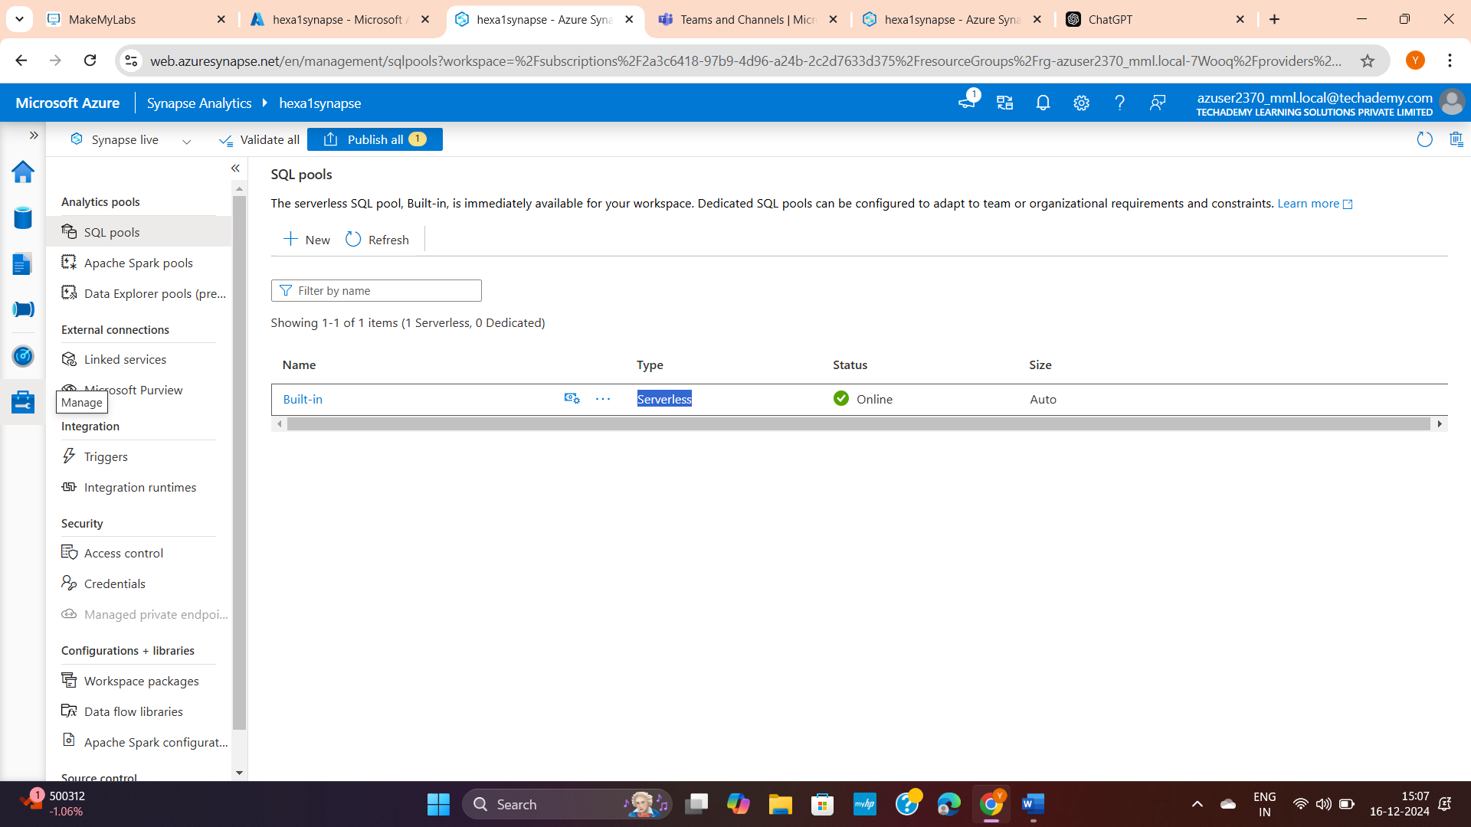

2 ways to use ADLS dataset without code:

1. Using dataflow
2. Using ingestion option in left

DATA FLOW:

You can use UI without code in data flow

